Chapter 8

SCREEN SHOTS AND USER MANUAL
______________________________________________

ADMISSION MODULE
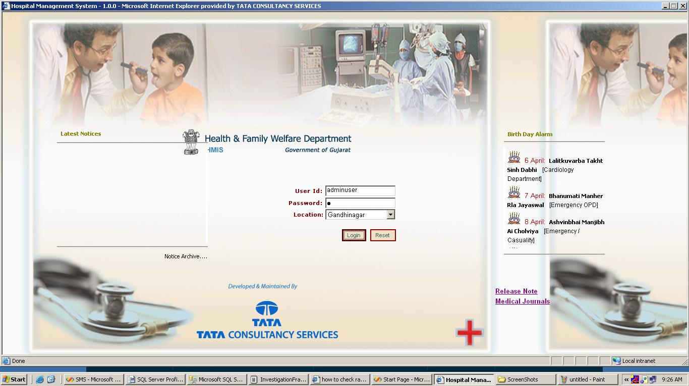
Fig 8.1 Screen shot showing login

- This is login screen.
- Login is done according to the role.

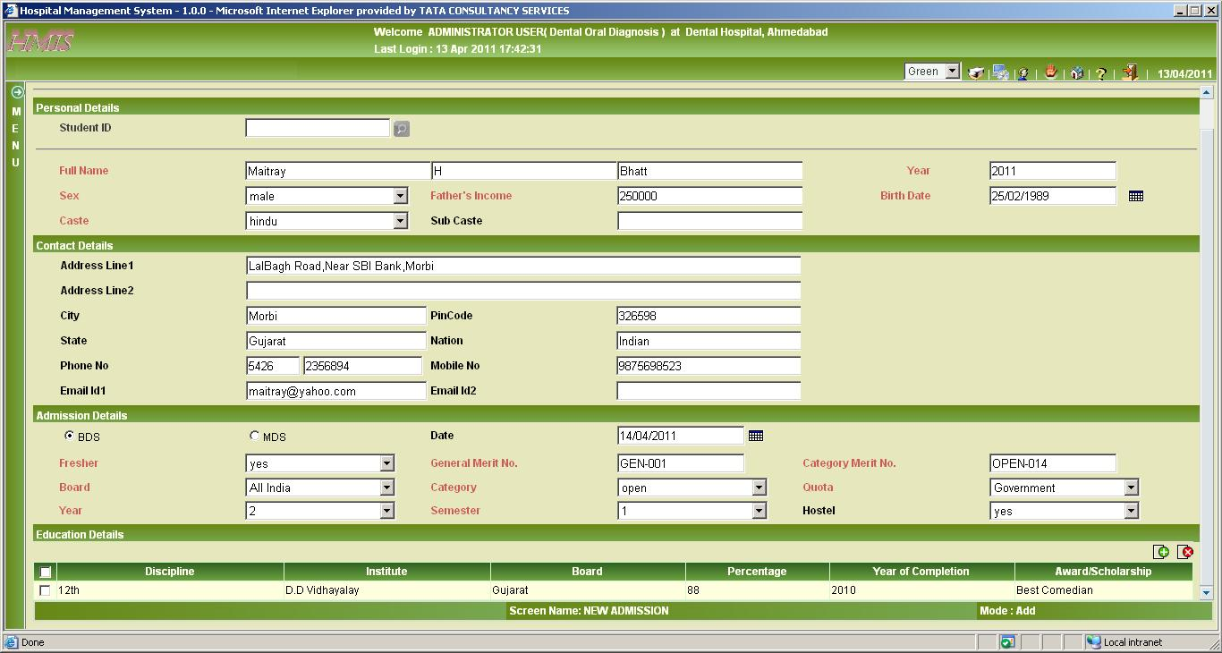
Fig 8.2 Screen shot showing new admission add mode

At the time of admission students information like personal details, contact details, admission details and education details are saved in the database and the student id is generated by the system.

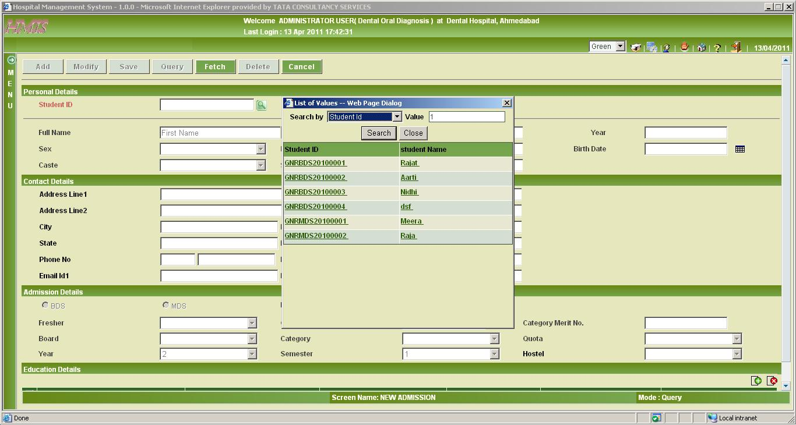
Fig 8.3 Screen shot showing new admission in query mode

In fetch mode as you can see when you click on the student id LoV it will display the list of students’ information (student id and name) according to the type of attribute you select whether it is student id or it may be student name. Now from the list of the students in the LoV you can select any one student and on that basis you can fetch his/her information.

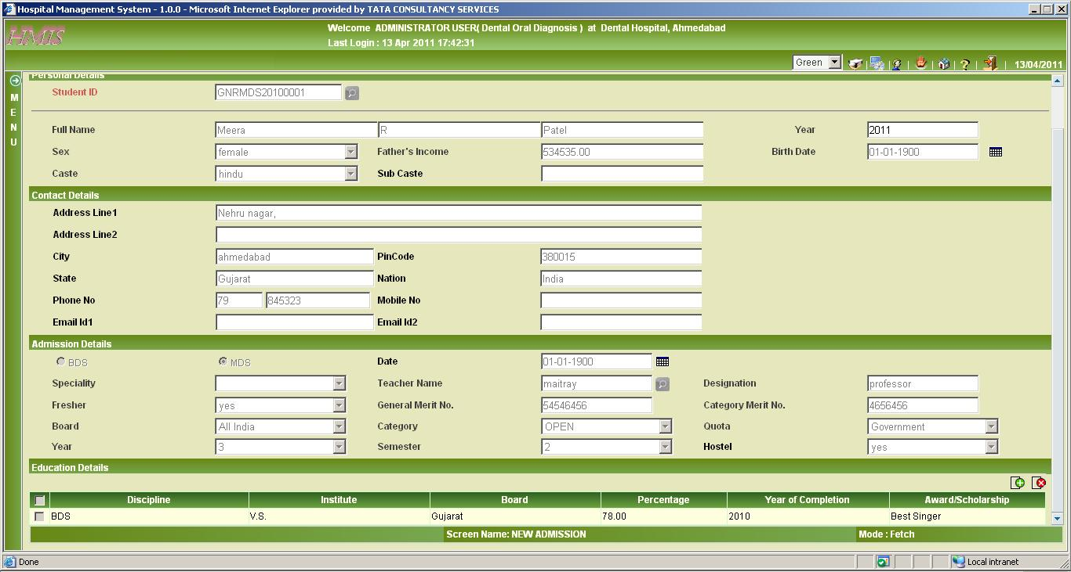
Fig 8.4 Screen shot showing new admission in fetch mode

In fetch mode according to student id you select from the LoV (list of values), when you click on the fetch all the information of the student will be displayed on the screen as shown in the figure.

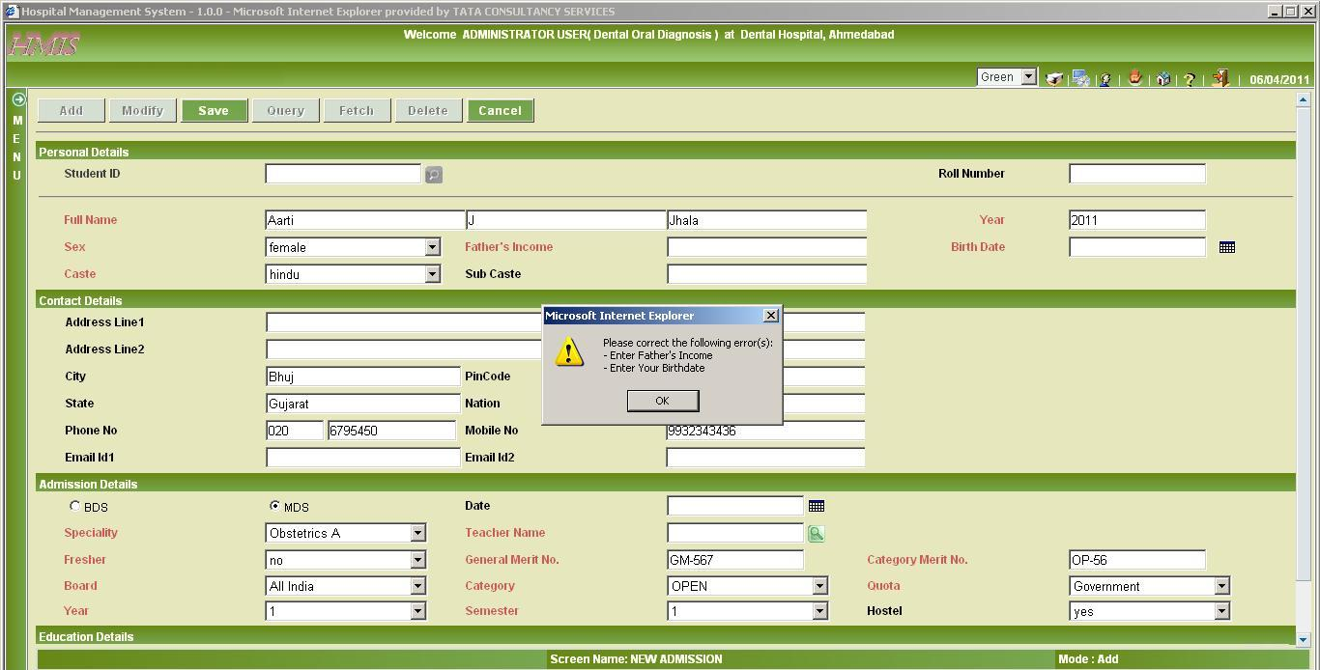
Fig 8.5 Screen shot showing validation in new admission in save mode

In Add Mode if mandatory fields are not mentioned and the user try to save, then system will prompt to fill the mandatory fields.

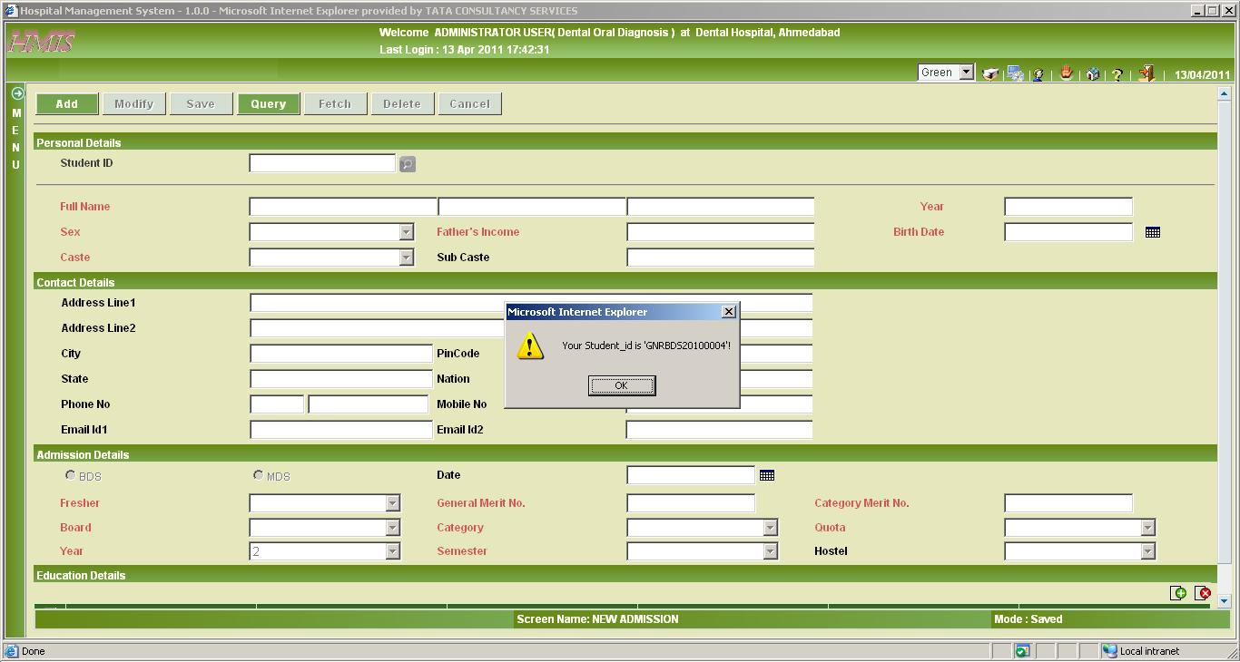
Fig 8.6 Screen shot showing new admission in Saved mode

In Saved mode, after clicking the Save button from the Button Bar, system will pop up a message box showing the current Student ID generated.

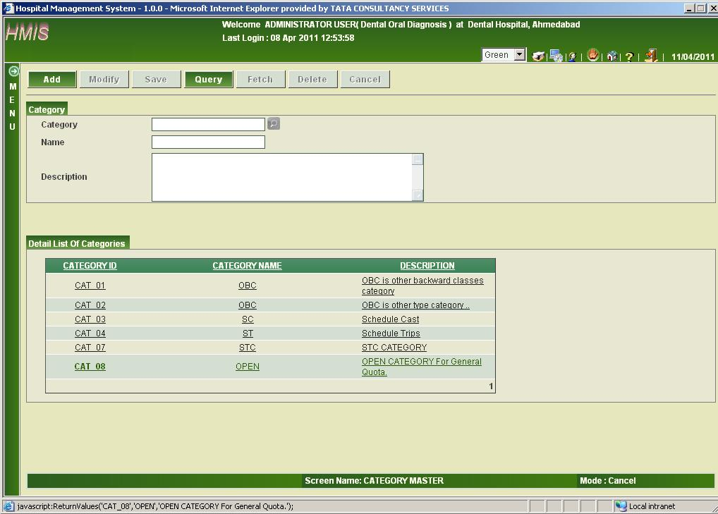
Fig 8.7 Screen shot showing Category Master in Cancel mode

In cancel mode, all the information of the category will be available by default which are category id, category name, description.

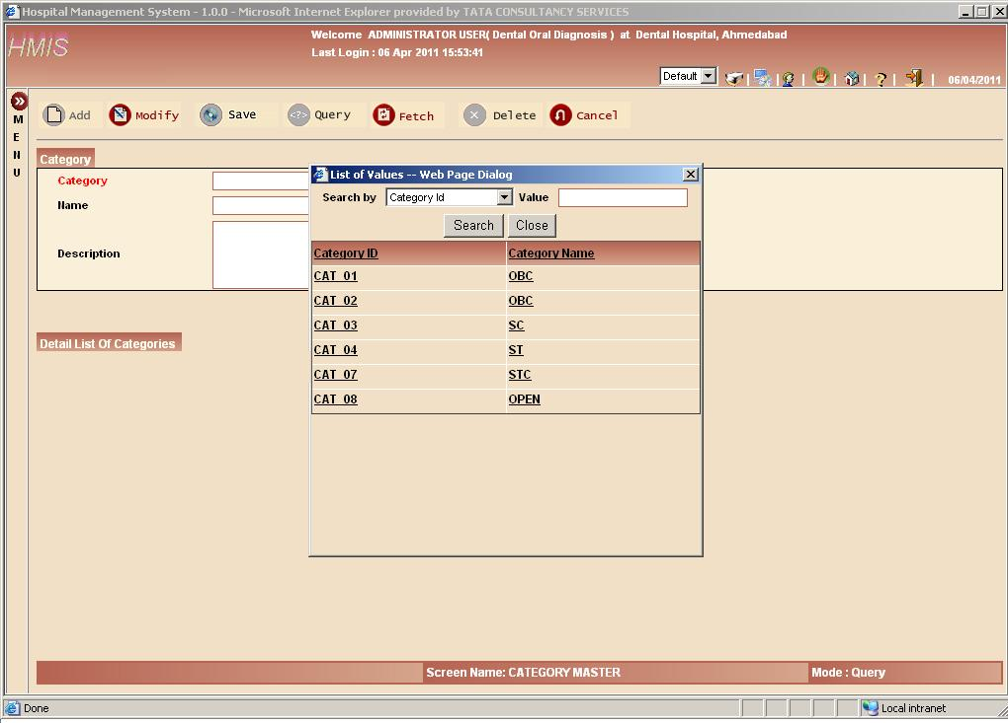
Fig 8.8 Screen shot showing Category Master in Query mode

In fetch mode as you can see when you click on the category LoV it will display the list of category’s information (category id and category name) according to the type of attribute you select whether it is category id or it may be category name. Now from the list of the category in the LoV you can select any one category and on that basis you can fetch information.
The screen is displayed in its default theme.

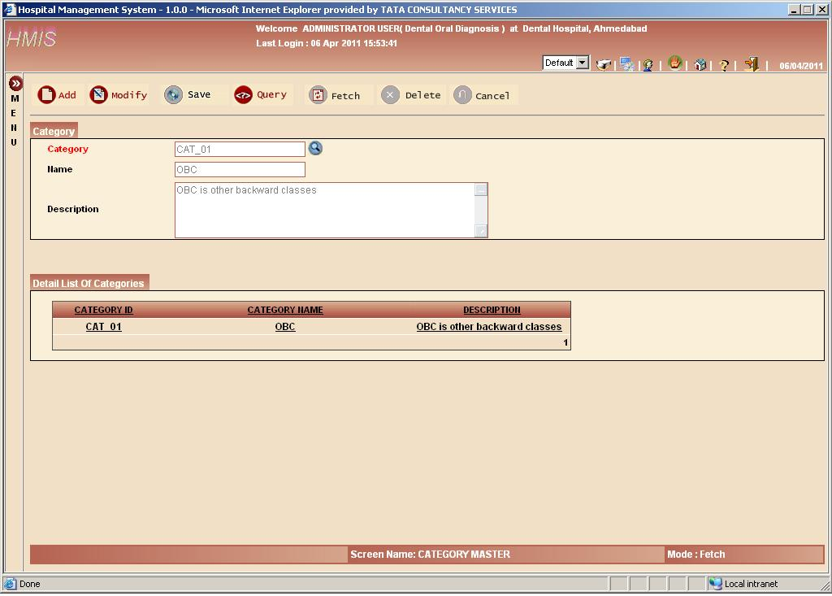
Fig 8.9 Screen shot showing Category Master in Fetch mode

In fetch mode according to category id you select from the LoV (list of values), when you click on the fetch all the information of the category will be displayed on the screen as shown in the figure.

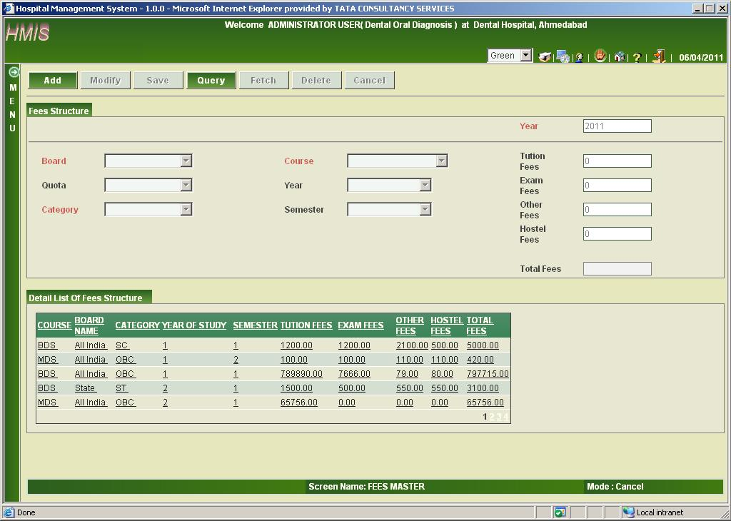
Fig 8.10 Screen shot showing Fees Master in Cancel mode

As show in the screen according to the board, category, quota, course for a particular semester fees is decided. Further the total fees are divided into tuitions fees, exam fees, other fees, hostel fees.
In cancel mode, all the information of the Fees will be available by default which are Course name, Board name, Category Name, Year of study, Semester, Tuition fees, Exam fees, Other fees, Hostel fees And Total fees.

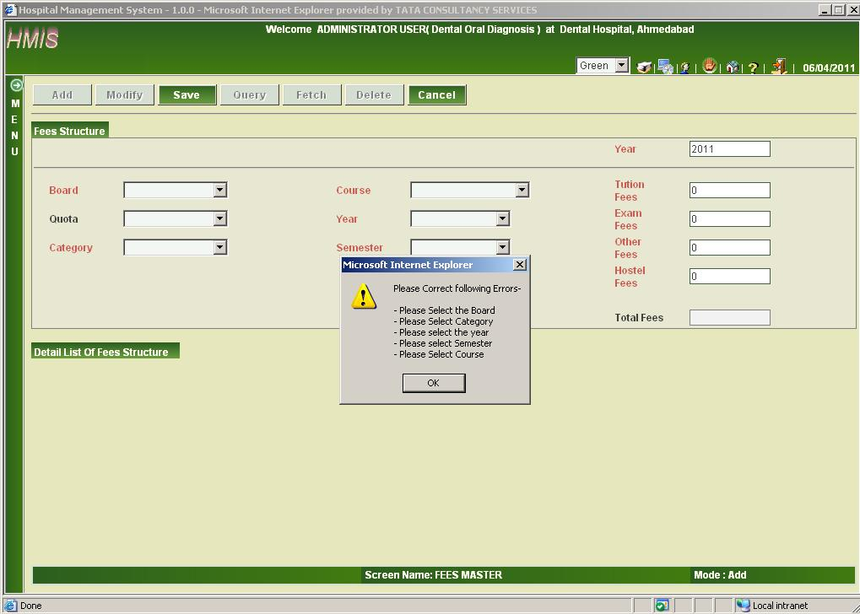
Fig 8.11 Screen shot showing validation in Fees Master in Save mode

If you click on save button and forget to enter any required information you will be immediately informed; As shown in the screen board, year, category, year, semester, course are empty so the message is prompted to the user.

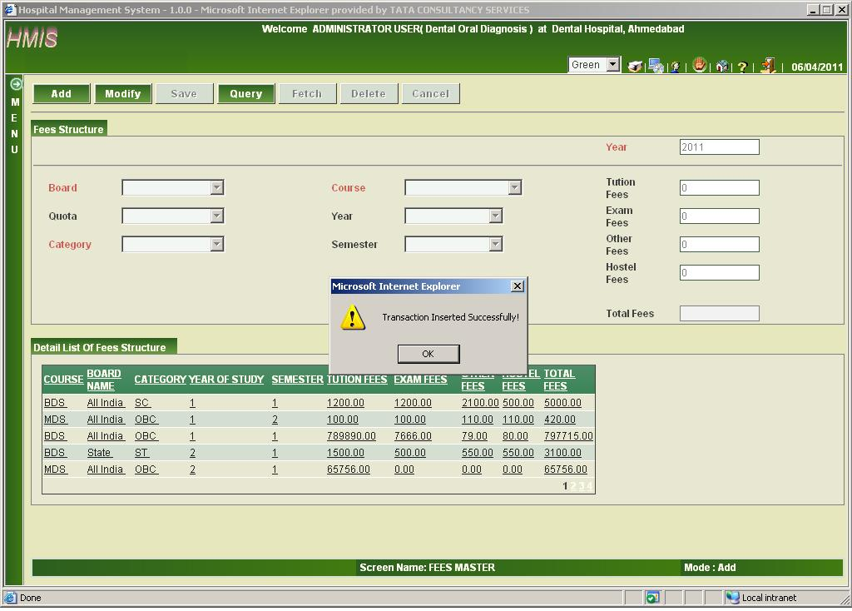
Fig 8.12 Screen shot showing Fees Master in Save mode

After providing all the information in the fees when you click on the save button the transaction is successfully saved in the database. A message will be displayed after the record is inserted in the database.

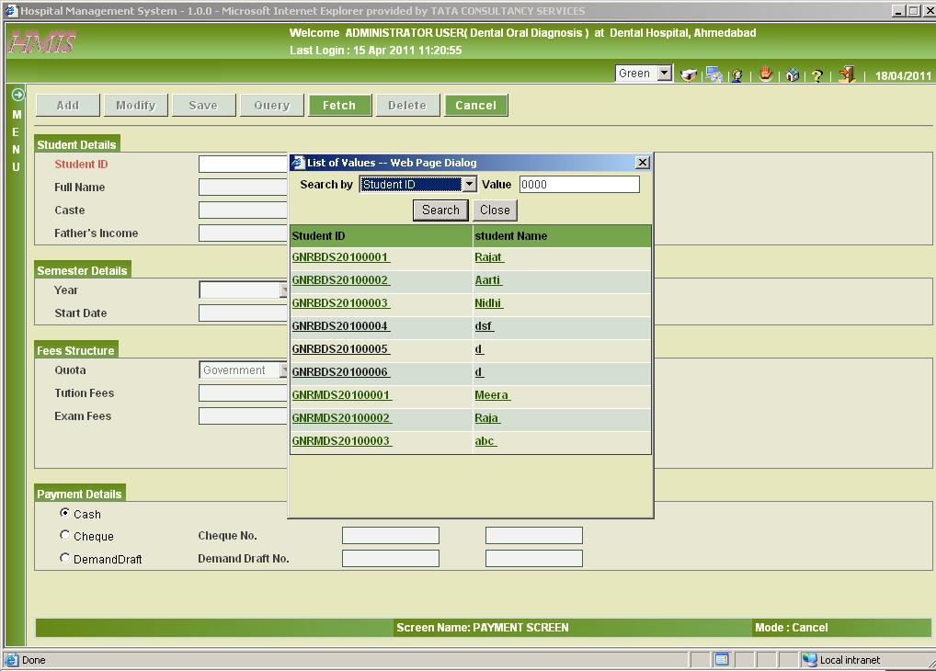
Fig 8.13 Screen shot showing Payment Screen in Query mode

In query mode, on clicking the LoV of Student Id, we get list of those students who has not paid their fees yet.

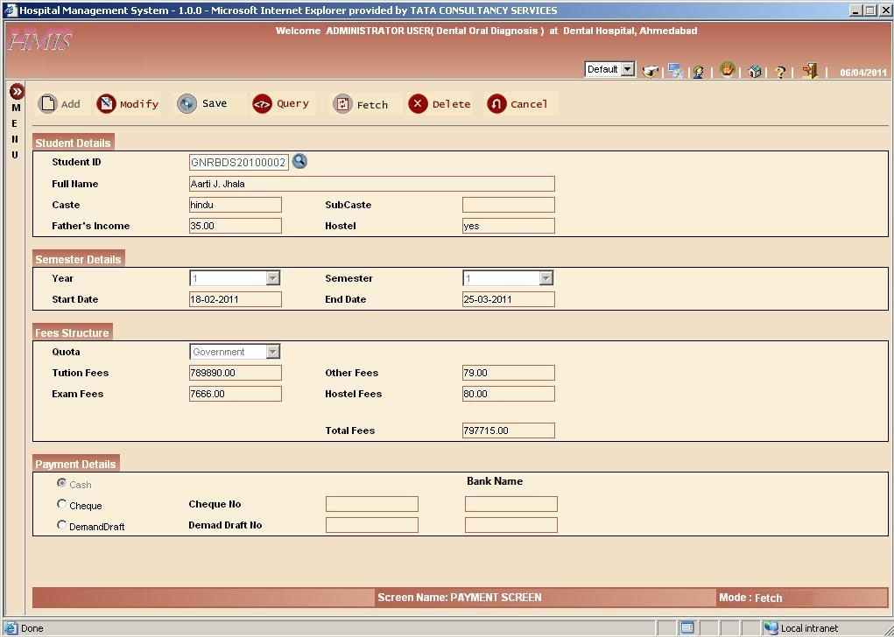
Fig 8.14 Screen shot showing Payment Screen in Fetch mode

According the student LoV you will get all the information of the student like student details, semester details, fees structure. The only information need to be entered is payment details whether the student want to enter the fees by cash, cheque or demand draft if the student want to pay the fees by the using demand draft or by cheque then cheque no and payee bank name or demand draft and its payee bank name is needed. After the save button is clicked then all the information will be saved in the system.

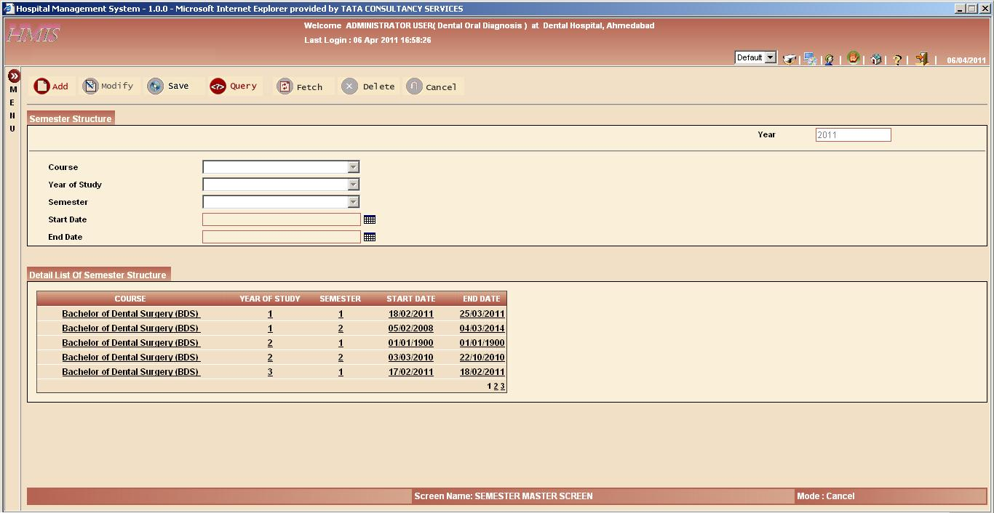
Fig 8.15 Screen shot showing Semester Master Screen in Cancel mode

Semester master screen contains the course, year of study, semester, start date; end date .this screen provides information of the starting and ending of the semester.
By default this screen in cancel mode, all information i.e., course name, year of study, semester, start date of semester and end date of semester are displayed on screen.

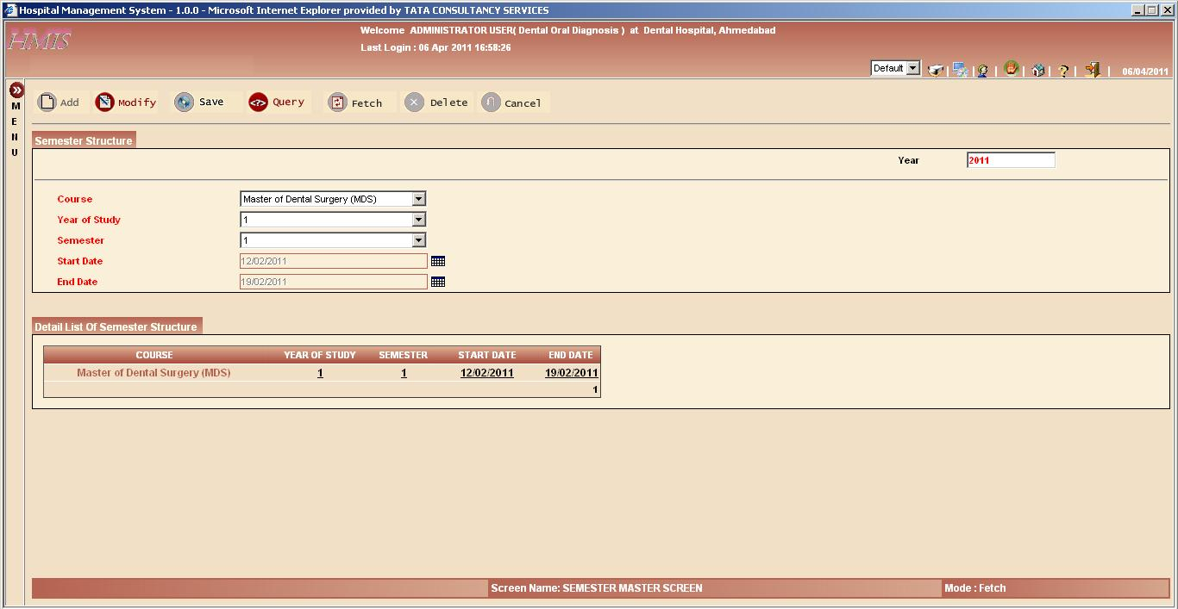
Fig 8.16 Screen shot showing Semester Master Screen in Fetch mode

On clicking the query button the course, year of study, semester becomes enabling. And you can select any course, year of study or semester from the list box.
On the basis of your selection, semester details are displayed on screen.

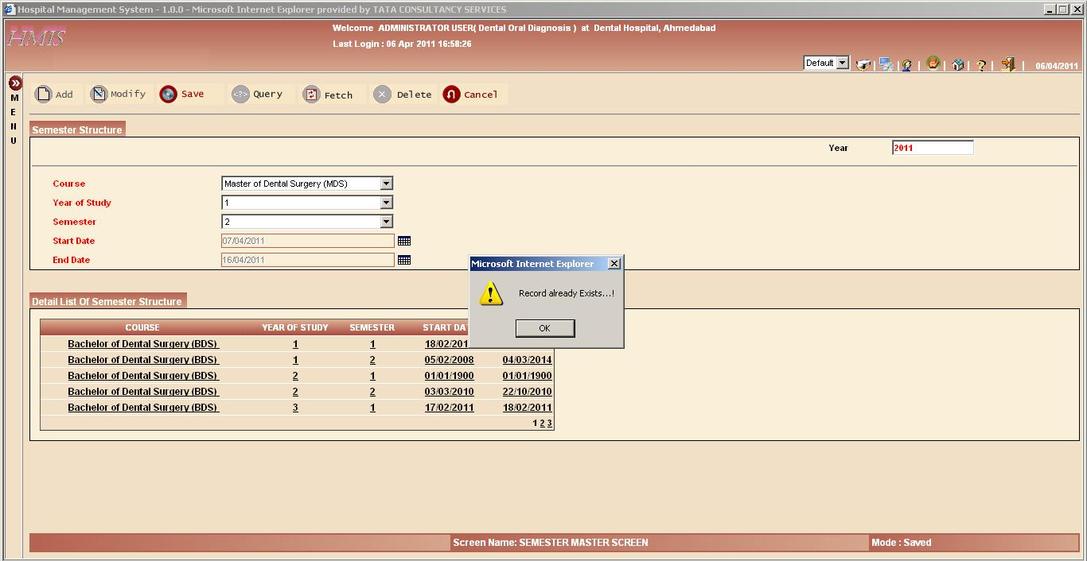
Fig 8.17 Screen shot showing Semester Master Screen in Save mode

If the user try to insert a record which is already exist then the user will be prompted by the message that record already exist.

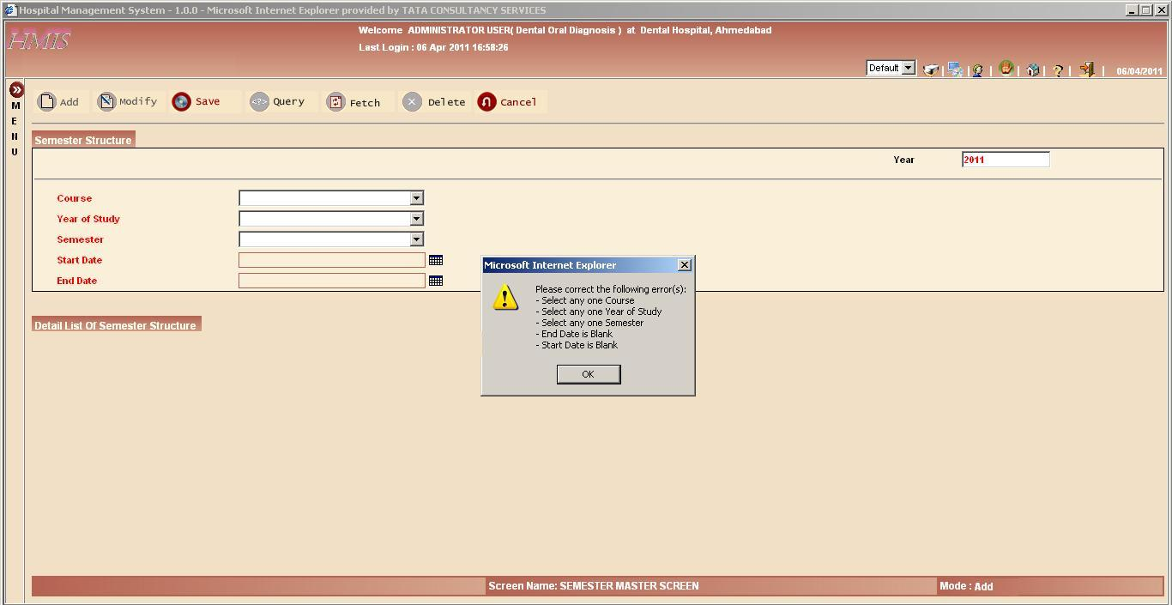
Fig 8.18 Screen shot showing validation in Semester Master Screen in Save mode

If the user click on the save button and the some textbox is empty the user will be immediately prompted by the message that something is missing.

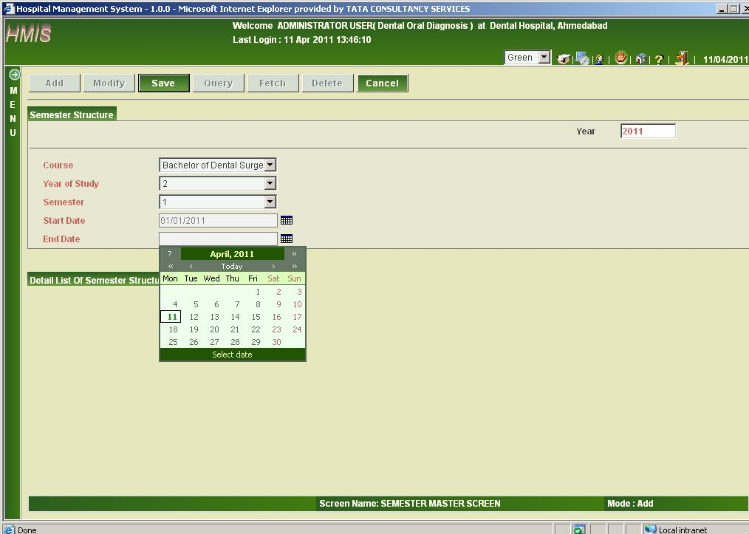
Fig 8.19 Screen shot showing Semester Master Screen in Add mode

As shown the add mode of the semester master screen in the green theme.

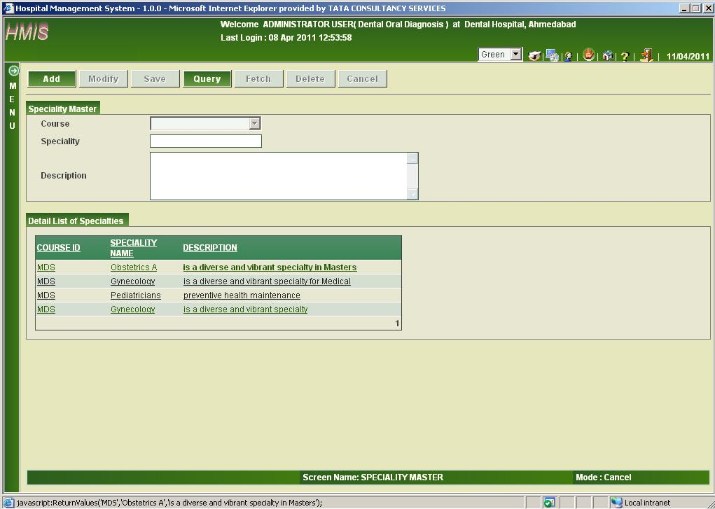
Fig 8.20 Screen shot showing Specialty Master Screen in Cancel mode

As shown, in cancel mode all the specialties will be shown by the system by default. The information shown includes Course Id, Specialty Name and Description of particular specialty.

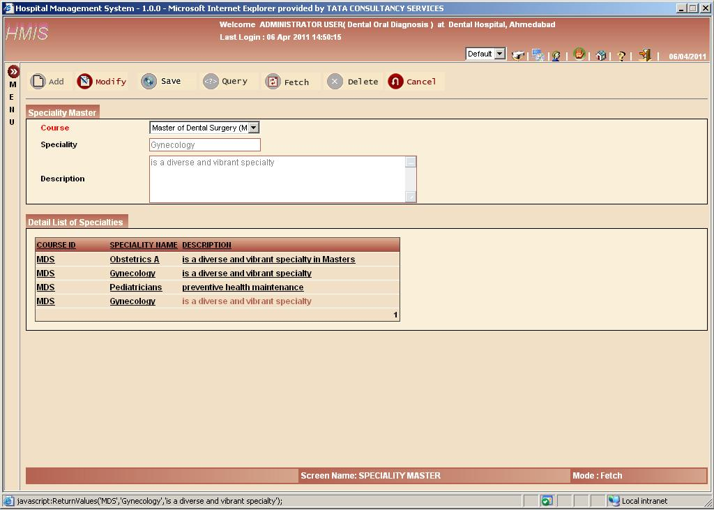
Fig 8.21 Screen shot showing Specialty Master Screen in Fetch mode

After clicking the query button, according to the course or speciality you can fetch the records from the database.
After clicking the fetch button, the records will be fetched according to the values provided in the speciality or course.

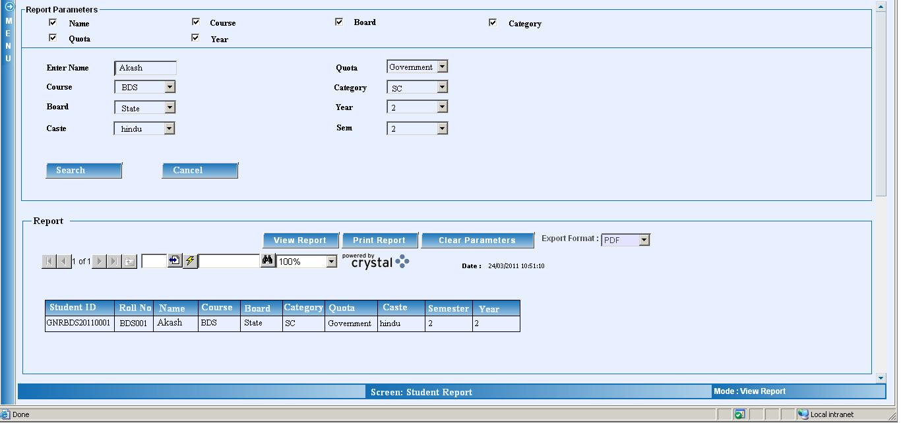
Fig 8.22 Screen shot showing student report generation

On the basis of the selection criteria the student report can be generated.

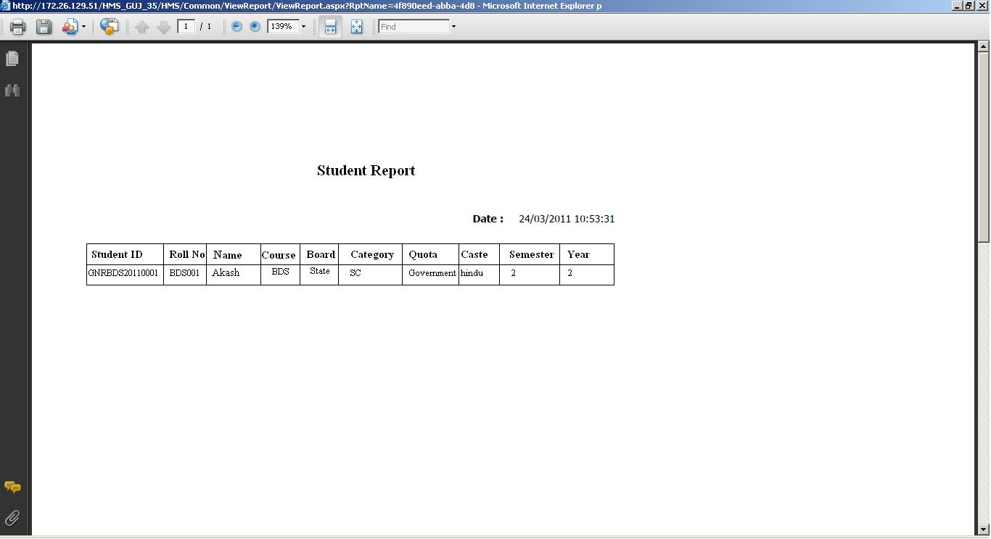
Fig 8.23 Screen shot showing student report

As shown in the figure the report of the student, we can take print of the report.

EXAMINATION MODULE
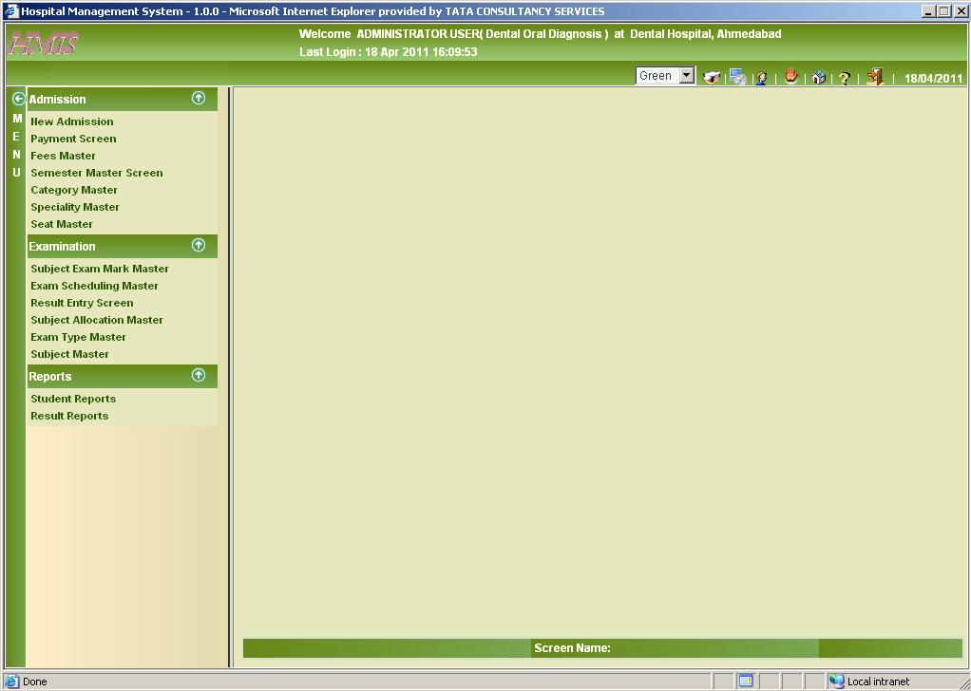
Fig 8.24 Screen shot showing Menu

In this screen, the menu is shown which contains the entire screen module wise and this menu is auto hidden when a screen name is clicked from the menu.

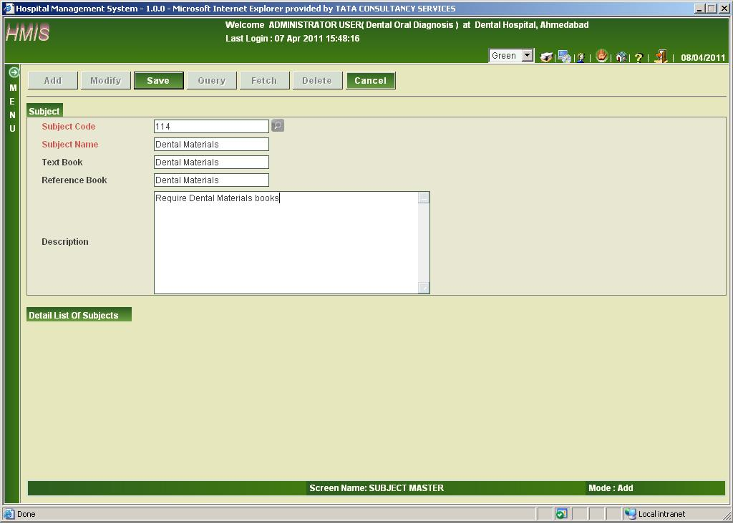
Fig 8.25 Screen shot showing Subject Master Screen in Add mode

In add mode, the subject code and subject name are mandatory and text book and reference book name, description are optional.

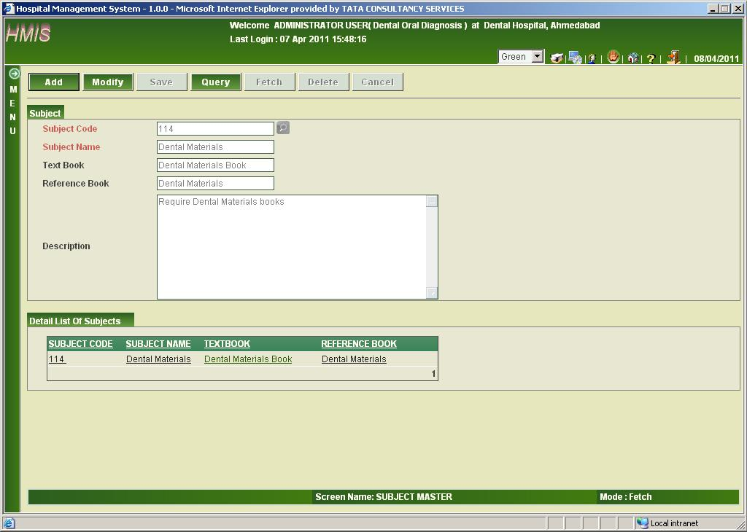
Fig 8.26 Screen shot showing Subject Master Screen in Fetch mode

According to the subject name or subject code the user can fetch the record from the database.

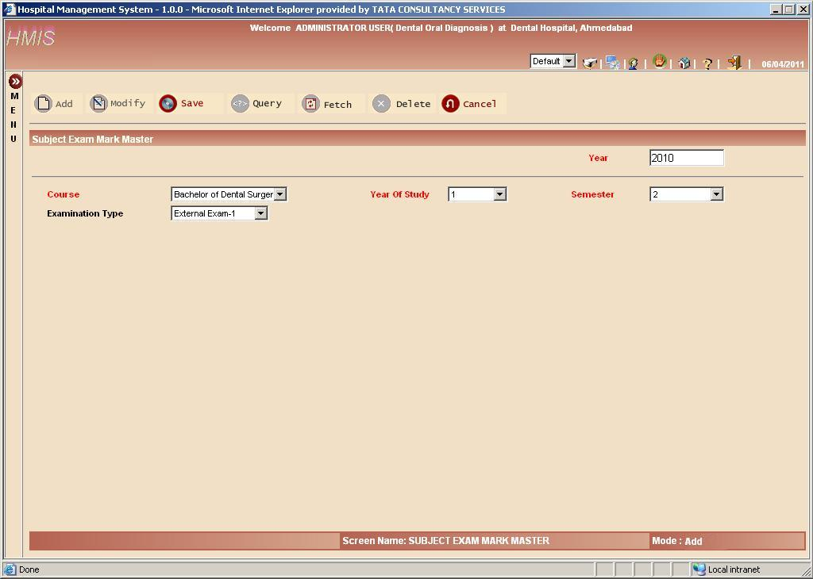
Fig 8.27 Screen shot showing Subject Exam Mark Master Screen in Add mode

As shown here you can manage the marks details in the subjects which belong to particular exam type.
Every entry will comprise of course, year, semester, exam type, subject, duration, passing marks, total marks.

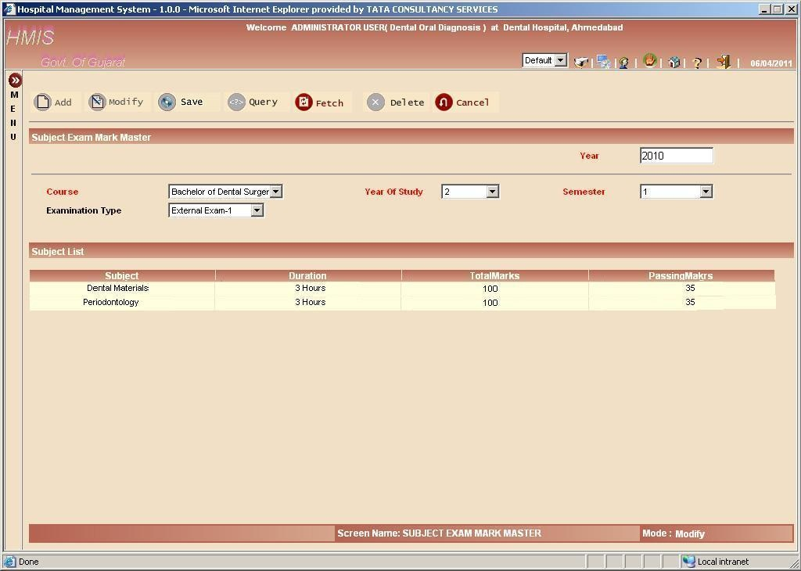
Fig 8.28 Screen shot showing Subject Exam Mark Master Screen in Modify mode

As shown the subject exam in modify mode user can modify the details of the marks, total marks, passing marks, duration.

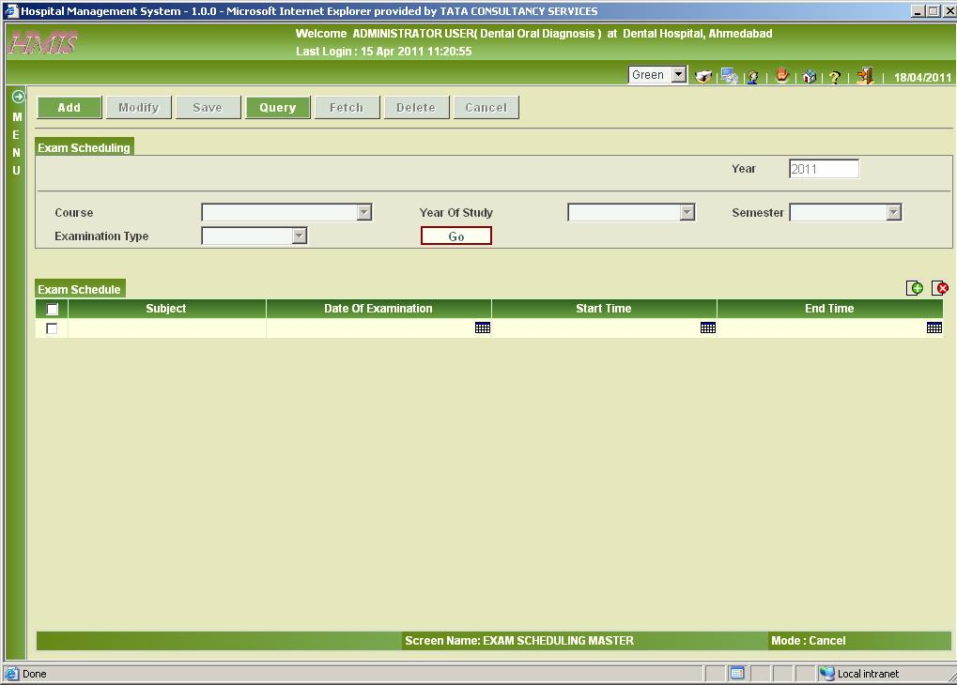
Fig 8.29 Screen shot showing Exam Scheduling Screen in Cancel mode

This is the first screen which appears when the when the exam scheduling screen is loaded first time. It is in the Green theme.

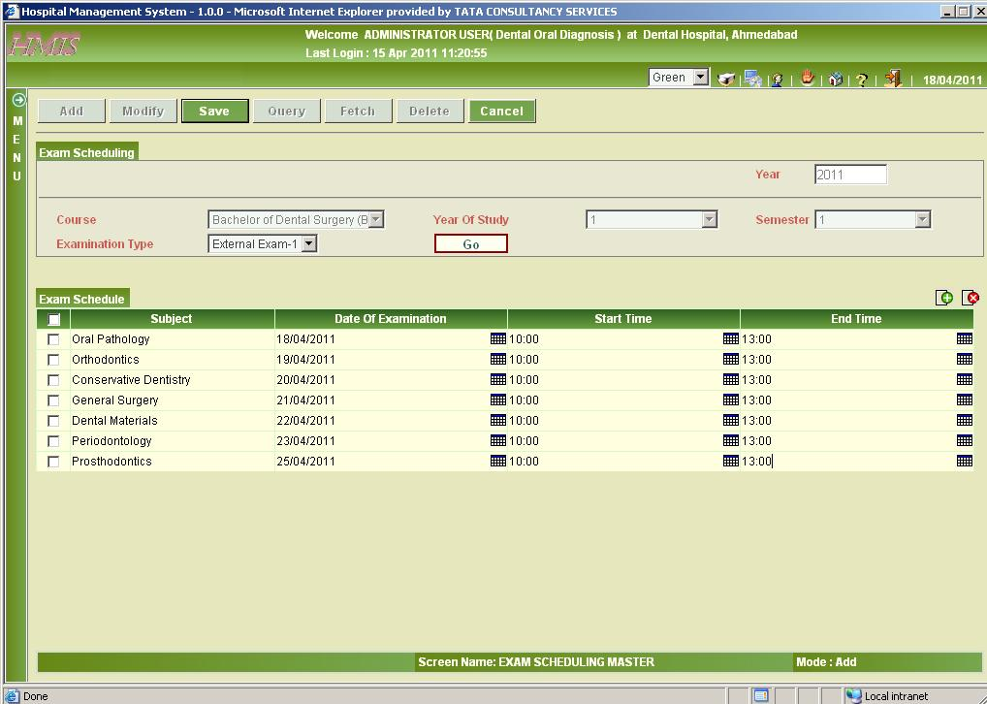
Fig 8.30 Screen shot showing Exam Scheduling Screen in Add mode

After selection of particular course, year and semester, on clicking Go button; it displays list of subjects of that particular selection.
The date of examination, start time and end time is inserted and after clicking the save button and successful insertion of records, the system displays a “transaction successfully” message to the user.

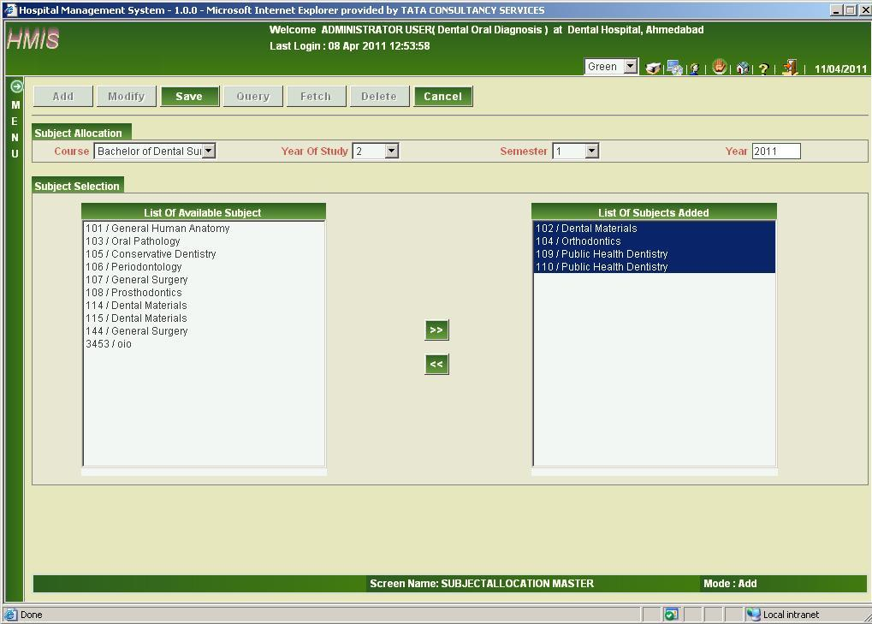
Fig 8.31 Screen shot showing Subject Allocation Master Screen in Add mode

As shown subject allocation in add mode according to the course, year, semester the list of the subject will be added to them.

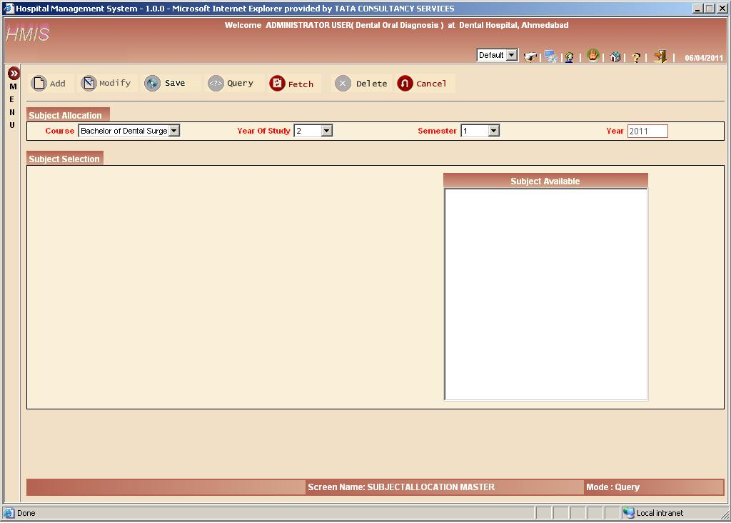
Fig 8.32 Screen shot showing Subject Allocation Master Screen in Query mode

In query mode the user is required to select course or year or semester or all the three combination to fetch the record from the database.

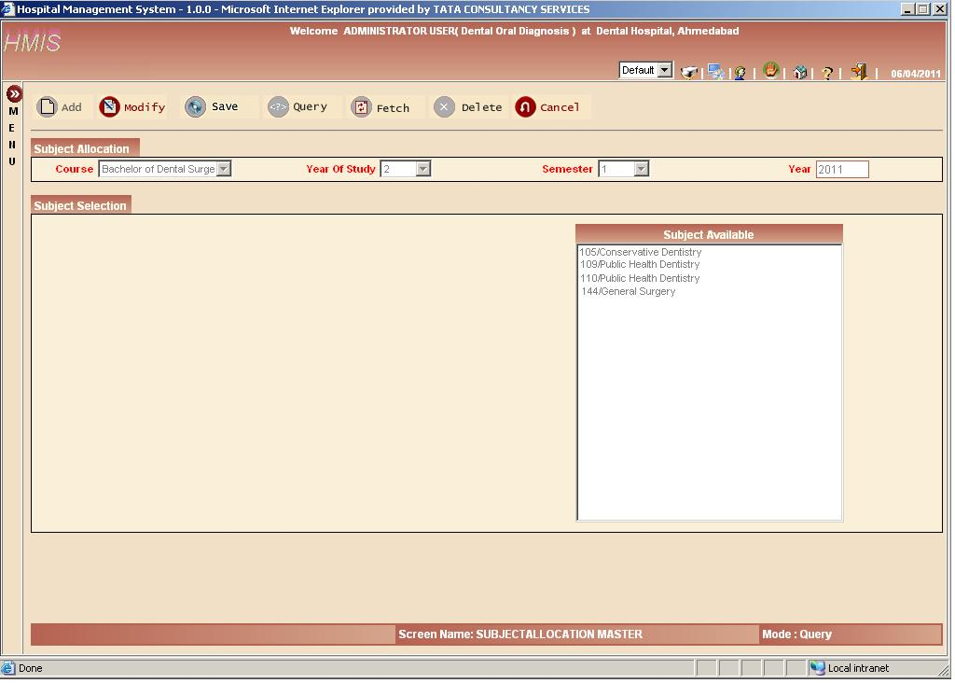
Fig 8.33 Screen shot showing Subject Allocation Master Screen in Fetch mode

After entering the information in the course, year, semester when you click on the fetch the lists of the subject which are available will b shown in the list box.

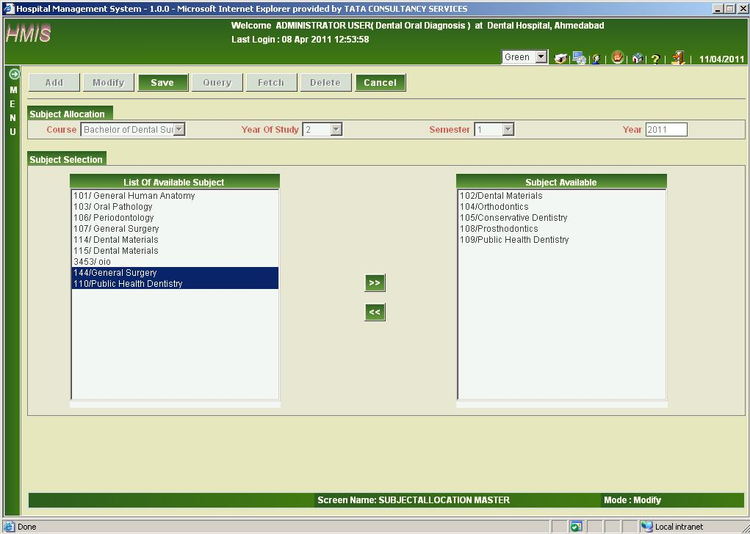
Fig 8.34 Screen shot showing Subject Allocation Master Screen in Modify mode

In modify mode more subject can be added or removed using the two buttons shown in the screen shot.

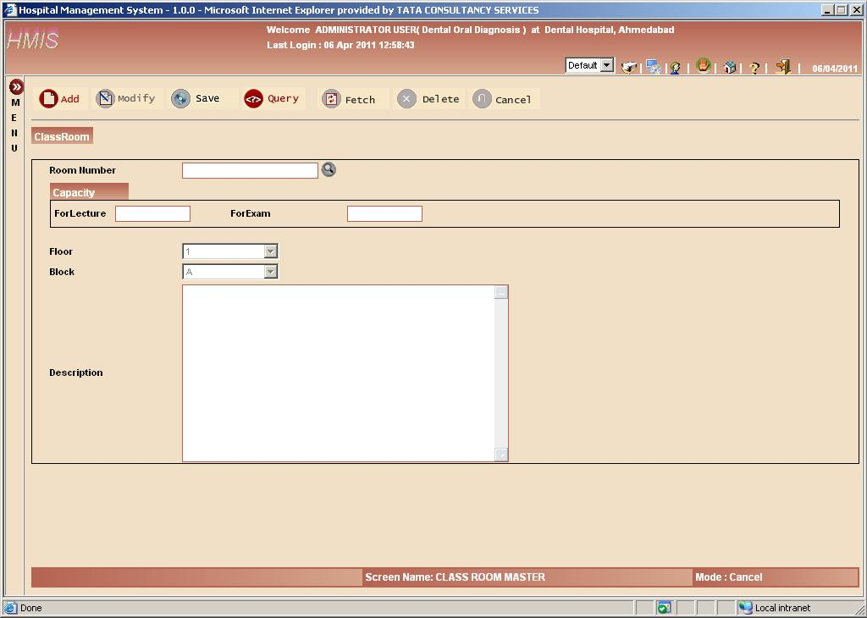
Fig 8.35 Screen shot showing Class Room Screen in Cancel mode

The Class Room screen is useful in adding capacity in case of lecture or examination. In case of examination small number of students are assigned in particular room as compared to lecture.
Floor and block number is added for more specific location.

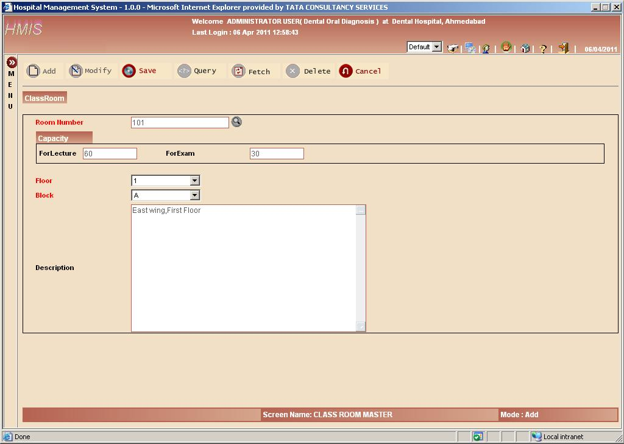
Fig 8.36 Screen shot showing Class Room Screen in Add mode

In add mode, for particular room number, capacity for lecture and examination is assigned and more specific location is displayed by adding more information to data like floor number and block name.

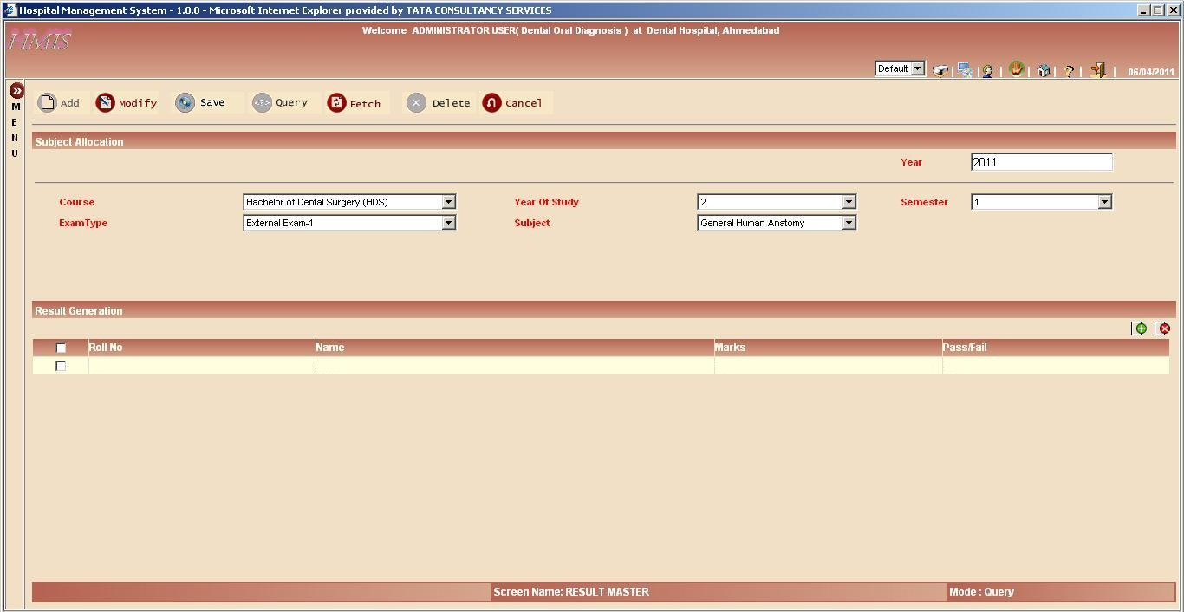
Fig 8.37 Screen shot showing Result Entry Screen in Cancel mode

In this screen the marks and the pass/fail detail of the particular student for particular semester is stored in the database.

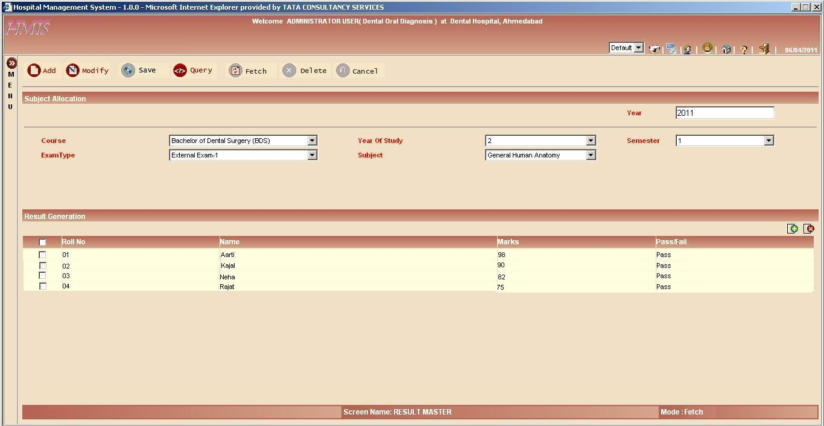
Fig 8.38 Screen shot showing Result Entry Screen in Fetch mode

For a particular subject, students are pass/fail are entered on this mode and then stored successfully in the database.

